DEPARTMENT OF COMPUTER SCIENCE AND ENGINEERING
ISLAMIC UNIVERSITY OF TECHNOLOGY
A SUBSIDIARY ORGAN OF OIC

LAB REPORT 4
CSE 4512: COMPUTER NETWORKING LAB
Name: Nayeemul Hasan Prince
Student ID: 220041125
Section: 1A
Semester: 5th
Date of Submission: 17.12.2025

1. Lab Task
The objective of this laboratory assignment was to implement a hybrid network topology that integrates two different dynamic routing protocols, RIPv2 and OSPF, and establishes communication between them using Route Redistribution.
Specific Objectives:
- Topology Design: Construct a network with three distinct zones: Lab Alpha, Lab Beta, and the ICT Department (Core).
- Addressing: Calculate subnets based on Student ID (25) following the formula: 192.168.(ID + n).0/24.
- Routing Implementation:
  - Configure RIPv2 for Lab Alpha.
  - Configure OSPF (Area 0) for Lab Beta.
  - Configure the Core Router to act as an Autonomous System Boundary Router (ASBR) to redistribute routes between RIP and OSPF.
- DHCP: Implement DHCP services on routers for their respective LANs.

2. Final Network Topology
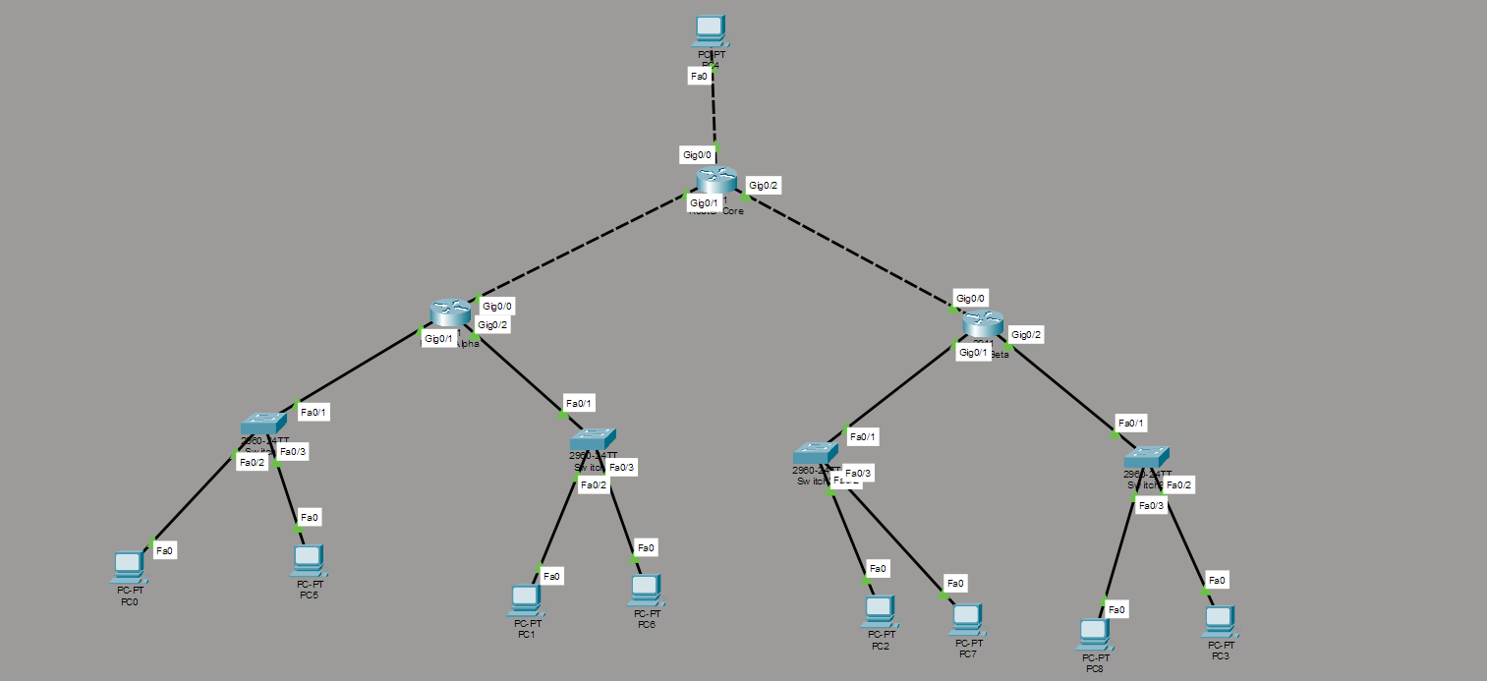

3. Procedure

Step 1: IP Addressing & Subnet Calculation
Based on Student ID 25, the following address scheme was devised:
Location | Network Address | Subnet Mask | Gateway IP | Protocol
Lab Alpha (LAN 1) | 192.168.25.0 | 255.255.255.0 | 192.168.25.1 | RIPv2
Lab Alpha (LAN 2) | 192.168.26.0 | 255.255.255.0 | 192.168.26.1 | RIPv2
Lab Beta (LAN 3) | 192.168.27.0 | 255.255.255.0 | 192.168.27.1 | OSPF
Lab Beta (LAN 4) | 192.168.28.0 | 255.255.255.0 | 192.168.28.1 | OSPF
ICT Dept (Core) | 192.168.29.0 | 255.255.255.0 | 192.168.29.1 | Both
WAN Link (Alpha-Core) | 10.0.0.0 | 255.255.255.252 | .1 (Alpha) / .2 (Core) | -
WAN Link (Beta-Core) | 10.0.0.4 | 255.255.255.252 | .5 (Beta) / .6 (Core) | -

Step 2: Physical Connections
- Three Cisco 2911 Routers were placed and renamed Router_Alpha, Router_Beta, and Router_Core.
- LAN connections were established using Copper Straight-Through cables from Switches to Router ports G0/0 and G0/1.
- WAN connections (Router-to-Router) were established using Gigabit Ethernet interfaces. Copper Cross-Over cables were used to connect Router_Alpha (G0/2) to Core_Router (G0/1) and Router_Beta (G0/2) to Core_Router (G0/2).

Step 3: Device Configuration
A. Router Alpha Configuration (RIP Zone)
Interfaces were configured, and RIPv2 was enabled to advertise the local LANs and the WAN link.

Router_Alpha(config)# interface g0/0
Router_Alpha(config-if)# ip address 192.168.25.1 255.255.255.0
Router_Alpha(config-if)# no shutdown
! (Repeated for G0/1 and WAN G0/2)
! DHCP Configuration
Router_Alpha(config)# ip dhcp pool ALPHA_LAN_25
Router_Alpha(dhcp-config)# network 192.168.25.0 255.255.255.0
Router_Alpha(dhcp-config)# default-router 192.168.25.1
! RIP Routing
Router_Alpha(config)# router rip
Router_Alpha(config-router)# version 2
Router_Alpha(config-router)# no auto-summary
Router_Alpha(config-router)# network 192.168.25.0
Router_Alpha(config-router)# network 192.168.26.0
Router_Alpha(config-router)# network 10.0.0.0
B. Router Beta Configuration (OSPF Zone)
Interfaces were configured, and OSPF Process ID 1 was enabled for Area 0.

Router_Beta(config)# router ospf 1
Router_Beta(config-router)# network 192.168.27.0 0.0.0.255 area 0
Router_Beta(config-router)# network 192.168.28.0 0.0.0.255 area 0
Router_Beta(config-router)# network 10.0.0.4 0.0.0.3 area 0
C. Core Router Configuration (Redistribution)
The Core Router was configured to run both protocols and redistribute routes between them.

! RIP Configuration (Interface towards Alpha)
Router(config)# router rip
Router(config-router)# version 2
Router(config-router)# network 10.0.0.0
Router(config-router)# redistribute ospf 1 metric 5
Router(config-router)# redistribute connected metric 1
! OSPF Configuration (Interface towards Beta)
Router(config)# router ospf 1
Router(config-router)# network 10.0.0.4 0.0.0.3 area 0
Router(config-router)# redistribute rip subnets
Router(config-router)# redistribute connected subnets

4. Observations & Results
A. Routing Table Verification
The routing table on Router_Beta was checked to ensure RIP routes from Alpha were successfully received via OSPF redistribution (marked as O E2).
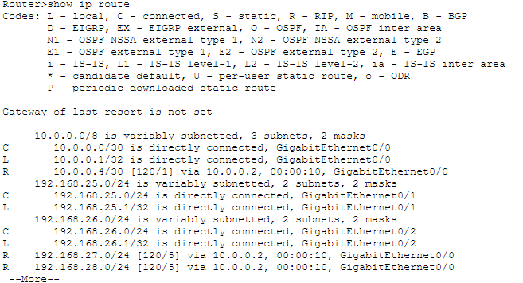
Fig: Router Alpha routes
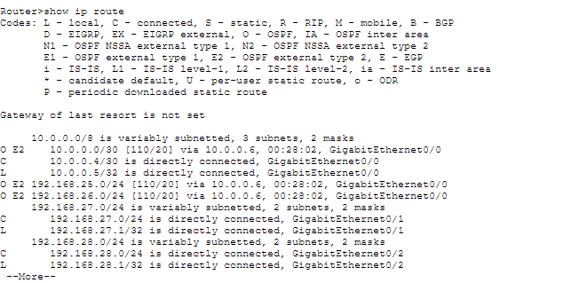
Fig: Router Beta routes

B. End-to-End Connectivity
A ping test was performed from a PC in Lab Alpha (192.168.25.x) to a PC in Lab Beta (192.168.27.x) to verify full network reachability.
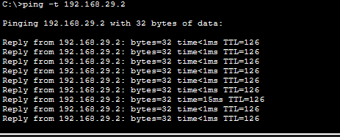

5. Challenges Faced
- Cable Selection for Gigabit Links: Initially, Copper Straight-Through cables were used for connecting the routers via Gigabit Ethernet ports, which resulted in link failure (Protocol Down). This was resolved by switching to Copper Cross-Over cables, which are required for connecting similar Layer 3 devices directly.
- Serial vs. Gigabit Interfaces: The initial lab instructions implied the use of Serial DCE/DTE cables. However, modern Gigabit interfaces do not support DCE clocking. We adapted the topology to use high-speed Ethernet WAN links, removing the need for clock rate commands and simplifies the physical setup.
- Redistribution Syntax: Determining the correct metric for redistributing OSPF into RIP was challenging. RIP requires a seed metric (hop count) to be manually defined (e.g., metric 5) because it cannot automatically translate OSPF's cost metric.

